1. **End-user Facing Documentation Example**

Gmail has a very powerful built-in feature you may not using, but can help keep your Gmail inbox more organized.

You can use a plus (**+**) sign to create multiple email addresses that will arrive in one Gmail account.

Here’s how to use it (and why!)

Simply add a plus sign (**+**) and any text between the personal portion of your Gmail address and **@gmail.com** to create a unique address. Any email sent using that modified address will be delivered to your Gmail account, but will include the extra characters.

Why is this such a great feature? Because it allows you to create new Gmail addresses for specific purposes, then easily organize, search, and filter for these special email addresses.

Let’s look at an example.

Say you subscribe to several online music services, and they all use **myname@gmail.com** as the username. Most sites will use your username as your contact email address, so new messages from any of these providers will be addressed to **myname@gmail.com**. If you wanted to get an alert whenever you received an email from any of your music sites, you’d need to set up multiple individual filters to get this done.

Using the plus sign (**+**) feature, **myname@gmail.com** can be modified by adding **+music** to become **myname+music@gmail.com**.By using **myname+music@gmail.com** as your account login or contact email, you can use the Search Options (Figure 1) to set up a filter to send the email to a label, or archive, delete, star, or automatically forward it to another address.

Figure - Access Gmail Search Options

You can use the Search Options (Figure 2) to create a label “Music Email”.

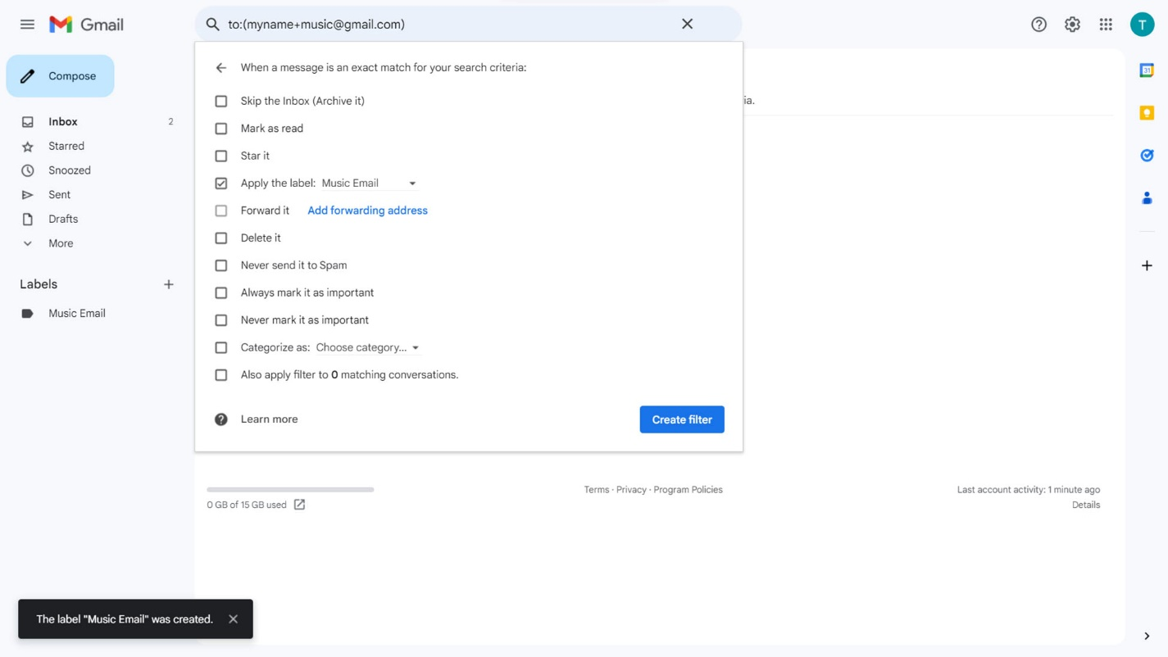

①

②

Figure 2 – Create a Label

Now, when an email to **myname+music@gmail.com** arrives, the Music Email label message counter (Figure 3) will show you.

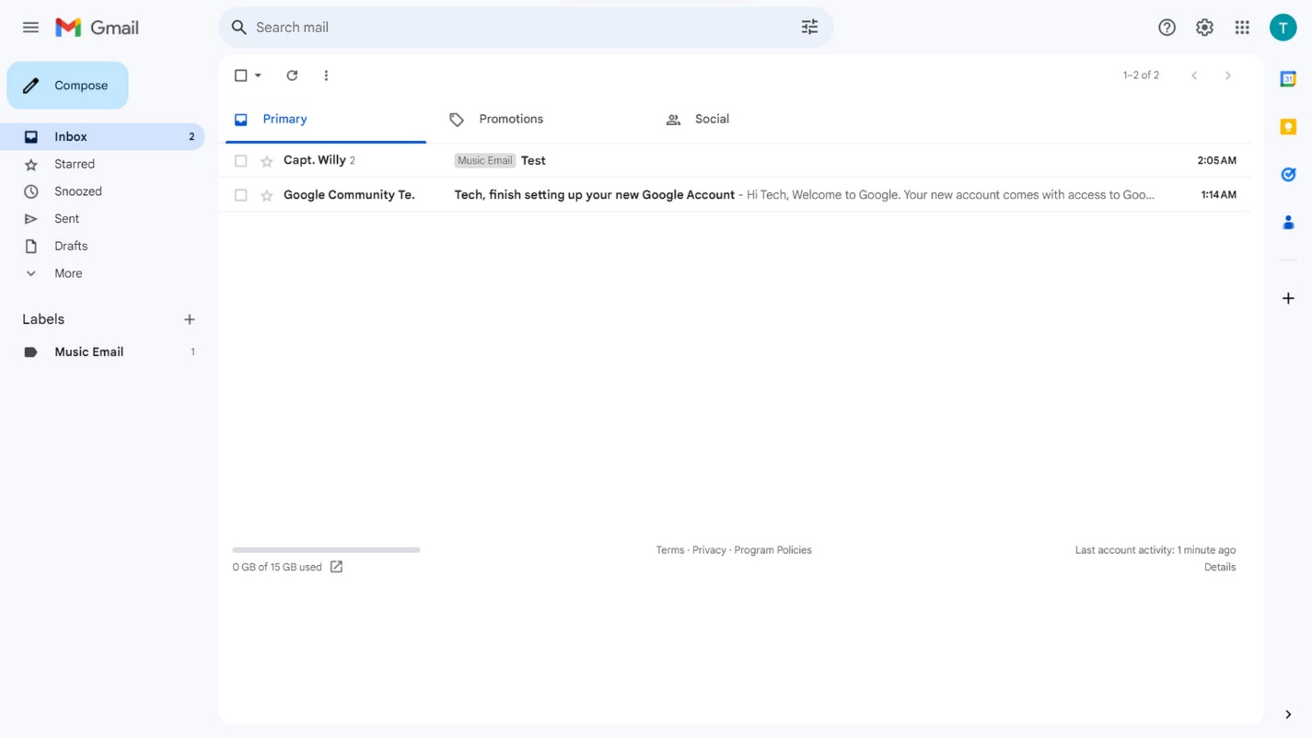

Figure 3 – Music Email Label Message Counter

1. **Recommendations for Documentation Locations**

* Gmail online Support→Help system
* Gmail Help Community site
* YouTube Gmail channel
* Facebook Gmail page

1. **Function: Route Gmail Emails Containing the Plus Sign (+)**

The **Gmail Plus Sign (+) Address Augmentation Function** utilizes the standard Google smart parser (assumption) to interpret and deliver properly formatted Gmail address variants as follows:

Parser scans for registered Gmail address, seeks “@” control character to initiate routing to valid recipient.

If parser identifies control character “+”, all characters preceding a “@” control character are retained.

When parser identifies “@” control character, email with extra characters is delivered to registered Gmail address.

registered.address+unique.characters@gmail.com

Note: all “.” characters are ignored by the Google/Gmail parsing logic and may be used without restriction for visual clarity.